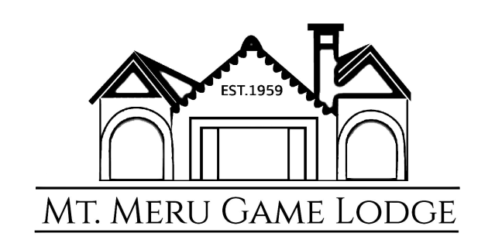

FACT SHEET

Introduction
Set in beautiful and tranquil surroundings, the Mount Meru Game Lodge is nestled between the Usa river and the wildlife sanctuary. The sanctuary is home to zebra, ostrich, water buffalo, a wide array of birds and monkeys, including the elusive colobus monkey. Conveniently located 25 minutes from Kilimanjaro International Airport (KIA), our lodge is an ideal starting point for your travels.
The lodge & sanctuary was established by Dr. Von Nagy in 1959 and remains in family hands till today. The lodge has grown in popularity over the years, and our visitors have included numerous presidents as well as members of European Royal families. We look forward to offering you a memorable experience during your stay in Arusha.

Location
The Mount Meru Game Lodge is equidistant from the city of Arusha and Kilimanjaro International Airport (KIA) - each an easy 30 minute drive on good roads. KIA, the closest international airport, is serviced daily by KLM flights, Turkish Airlines, Qatar Air and a number of African airlines.
Arusha holds the door to numerous world famous national parks and mountains, including the Serengeti National Park, the Ngorongoro Conservation Area, Mount Kilimanjaro and Mount Meru. The lodge provides an excellent staging point for those interested in visiting the parks or climbing the mountains.

Accommodation
The Lodge features a total of 18 guestrooms, comprising of 12 double rooms, 2 single rooms, 1 inter-connected family room, 1 large single unit family room and 2 triple rooms. Our double beds are 7 foot long by 6 foot wide (what some call super king). Our single beds are 7 foot long by 4 foot wide giving one plenty of space to enjoy a good night’s sleep.
- All rooms en suite.
- All rooms have WIFI
- All our rooms have room safes.
- Hair dryers/iron available at the reception.

The Lodge
The main building of the lodge was built sometime between 1920 and 1945 (most likely 1933) and consists of a reception area, lounge and bar. The lounge, with its enormous picture windows and comfortable furniture, provides for relaxation environment. The bar is well stocked with a wide selection of spirits, beers and minerals which are complemented by a carefully selected collection of wines. To the front of the main building is a terrace which is shaded by enormous old Mango trees and which enjoys magnificent views over mature, carefully tended gardens to the Sanctuary beyond.

In the grounds of the lodge can be found an outdoor dining area where you can enjoy the established gardens and view the animals in the sanctuary. In the evening a camp fire allows our guests to dine under the African star-lit sky whilst listening to the exotic night sounds. New additions to the lodge include a swimming pool where one can enjoy a few rays of sun.

Meals
An A la Carte Menu is available at the restaurant which is open from 11:00am to 11:00pm. The menu offers a wide assortment of freshly prepared meals.
For larger groups, a buffet menu can be arranged upon request.
For special dietary requirements/needs, please inform the waiter, cook or reception staff.

Shops
The lodge has two shops where one can buy African artifacts and souvenirs.
The first shop is a traditional African art shop where one can see how traditional carved woodwork is made. The owner of the shop is called Patrick Ndelwa, locally known as Moki. Patrick has been at the lodge since he was a young boy. His father Mzee Ndelwa did some work for Dr. Von Nagy in 1973. A close friendship was formed between Dr. von Nagy and Mzee Ndelwa which resulted in Mzee Ndelwa setting up a shop on the property where he remained for 41 years. Patrick was taught the art of craftsmanship by his father and has continued his father’s legacy to date.
The second shop is a small gift shop run by our very own lodge manager, Christine Maucha. Christine through her little shop, tries to support local artists and Maasai women by stocking the shop with some of their products.

Our Activities
MOUNTAIN BIKING
This ride will take you through the farms and villages at the foot of Mount Meru and surrounding areas. Rides are generally 2 to 3 hours long and can be tailored to any fitness levels.
Mountain Biking 35 USD Per Person

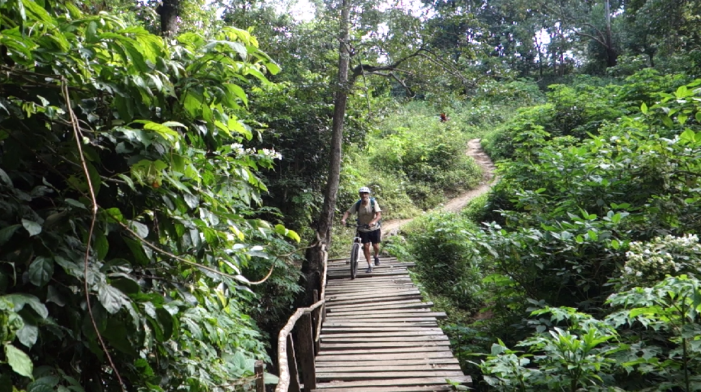

DULUTI FOREST WALK
Enjoy the coolness of the forest with lots of birds and monkeys overhead. Our naturalist will lead the way and explain the flora and fauna of the area (It Takes about 1½ - 2 hours).
Lake Duluti Walk 35 USD per person + 30 USD Transport per minibus (1 to 5 people)

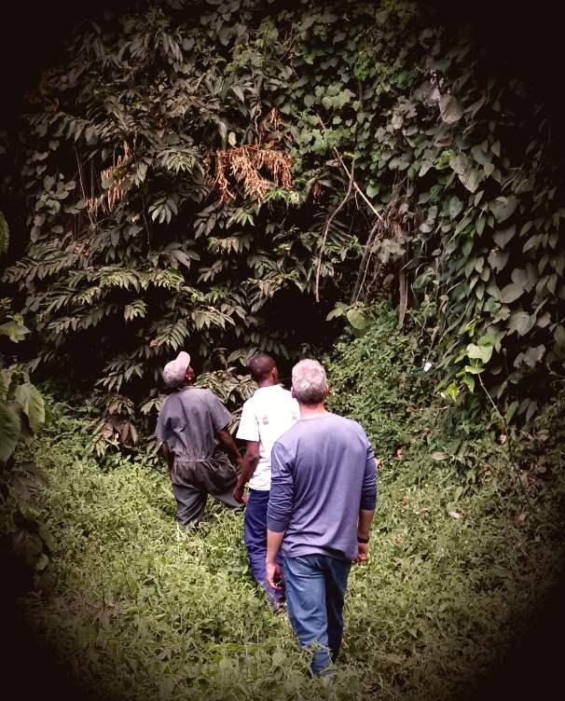

CANOEING SAFARI @ LAKE DULUTI
This is in a small peaceful Crater Lake (Lake Duluti) that is located close to Arusha town. You will enjoy a 2 hour canoe ride while viewing water birds and the pristine surrounding forest.
It is the best way to spend a relaxing morning or lazy afternoon on water and in touch with nature.

Canoeing 35 USD per person + 30 USD for Transport per minibus (1 to 5 people)

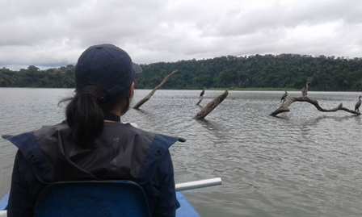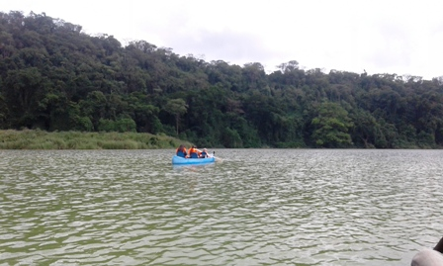

COFFEE TOUR
Take a tour in a local coffee farm and learn how farmers plant coffee trees, take care of the plantation and pick ripe coffee berries. Experience different steps from drying, roasting and grinding. Make your own cup of coffee while enjoying a magnificent view of the Lake Duluti (two to three hours).

Coffee Tour 30 USD pp + 30 USD for Transport per minibus (1 to 5 people)

CULTURAL/ EDUCATIONAL WALK
Mount Meru Game Lodge offers unique ‘Cultural and Educational’ walks into Usa River, a small township of approximately 20,000 inhabitants located a few minutes on foot from the property. These walks provide a unique insight to our guests, without the nuisance factor of hawkers, on what authentic life for Tanzanians really entails. They are guided by our own staff, are offered free of charge to guests of the lodge and are very much appreciated by all who participate in them. (The walk takes about two hours).
Cultural & Educational walks offered Free of Charge

