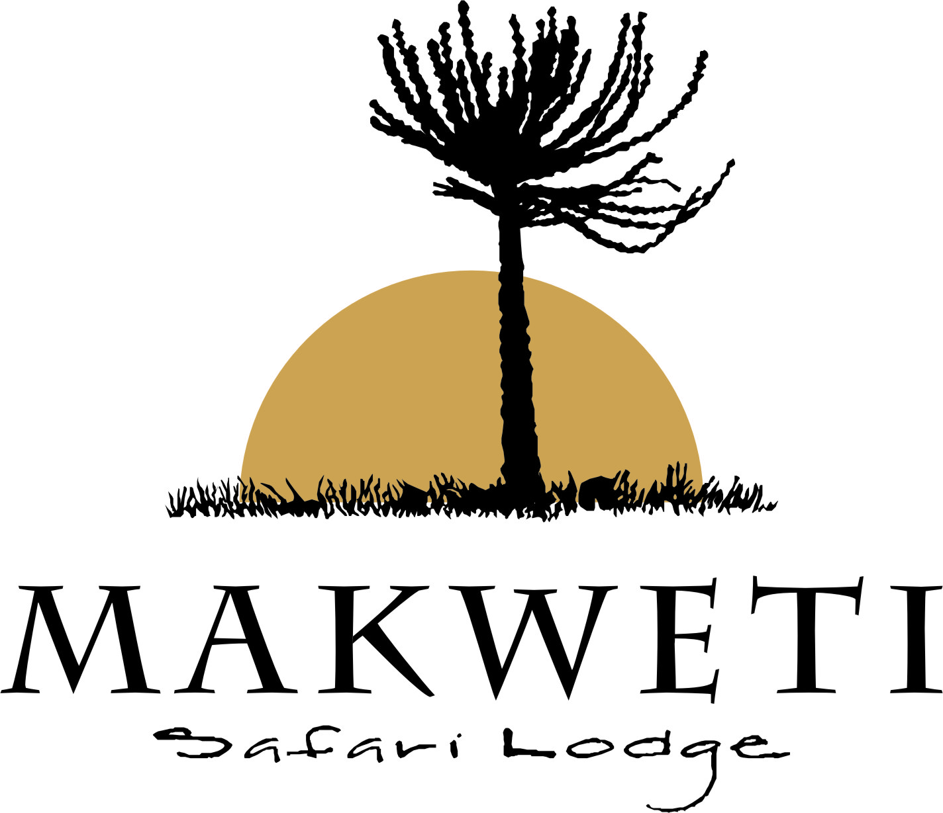

SPA TREATMENTS

At Makweti we offer a range of relaxing treatments, either the treatment room at the Indaba Lounge or on your private deck. To make a booking please enquire at reception.

Body Massage: A hydrating relaxing and rejuvenating massage that not only works the body but revitalizes the mind too, by using a unique range of Africology body balms and essential oils of your choice

R650 60mins Full Body
R450 30mins Back Neck and Shoulders

Itonga Massage: A deep tissue massage, using a variety of massage techniques including bamboo massage ‘poles’ to deeply penetrate and massage the muscles and body tissues
while using a unique combination of massage and detox oils that will leave your skin feeling toned and refreshed.

R650 60mins Full Body
R450 30mins Back neck and Shoulders

Foot Massage: detoxing, relaxing and revitalizing foot massage which incorporates essential oils that are psychologically grounding, calming and stabilizing.

R450 30mins

Makweti Signature Treatment: delightful duo – 30 minute back, neck and shoulder massage combined with a mini foot massage and relaxing head massage. All using our special range of Africology Products.

R800 80mins

