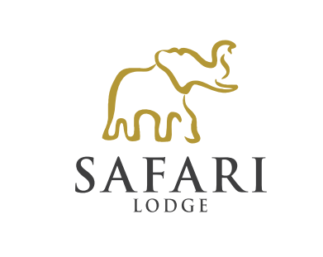

WEDDING PACKAGE AT THE SAFARI LODGE ON AMAKHALA GAME RESERVE
VALID 01.10.2022 – 30.09.2023

Chapel or Outdoor Ceremony
Venue, Minister and a pre - Wedding consultation with minister (mandatory) 10 000.00
Traditional Xhosa Choir – At wedding ceremony and during signing of the register 1 500.00
Flowers – Bridal Bouquet, 1 table arrangement (Based on main flowers being proteas).
A separate quote will be done should the bride want anything else. 1 500.00
4 Course dinner (existing menu’s) incl in accommodation price
Basic Wedding cake 750.00
Full Body Massage for bride & groom 1 800.00
Private Vehicle for the duration of the ceremony 2 500.00

Not included:
Applicable seasonal rate for accommodation per person per night (min 2 nights)
Photographer
Hairdresser and make-up artist

