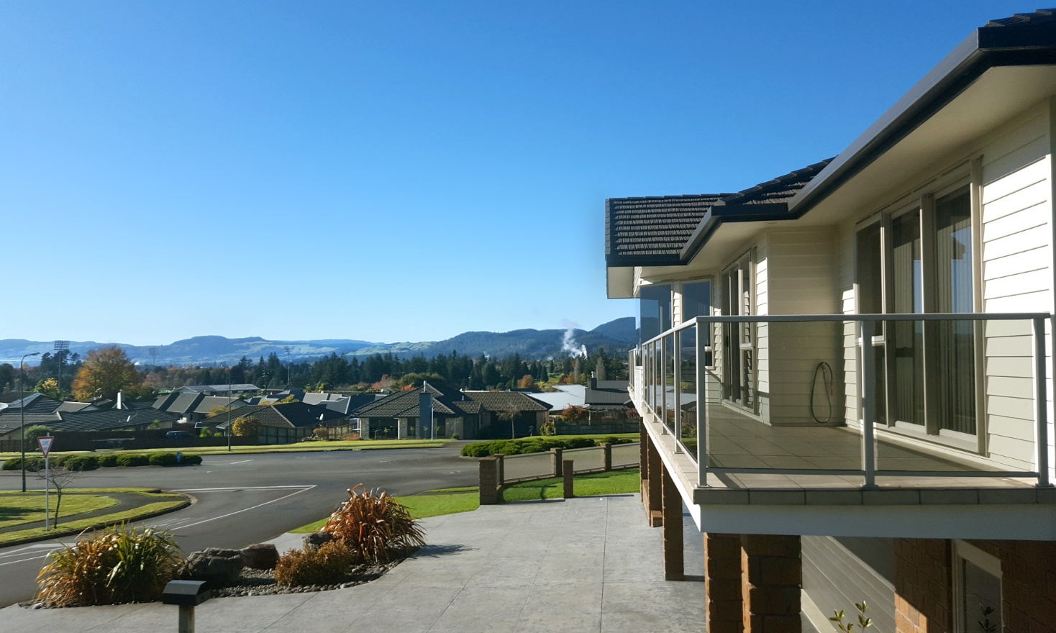

2 Linden Place, Matipo Heights, Rotorua 3015

Annie and Dale extend a warm welcome to you here at Rotorua Views.
Our aim is to make your stay enjoyable and for you to feel relaxed and comfortable. We have tried to provide everything we think you’ll need during your stay but if there is anything we have forgotten, please ask and we’ll do our best to accommodate your request.

For free Wi-Fi, choose RotoruaViews-5 or RotoruaViews-24
The password is: anniedale3015

General Information

- Smoking policy: A friendly reminder that we are a completely non-smoking house, including balconies. You are welcome to smoke outside on the lawn.

- Breakfast is served between 7.45 and 9.00am in the guest dining/lounge area. Please make your breakfast choices on the form provided and give it to us by 10pm the night before (or leave on the console table in the entrance hall).

- TV: turn on by pressing the Power button on the remote and then choose channels using the numbers. Free to air channels include TV1 (1), TV2 (2), TV (3), Prime (10), Choice (12), Duke (13) and Al Jazeera (16). To watch Netflix, press the Netflix button. Then choose ‘Andrea’ and make your selection from there.

- Attractions: Help yourselves to brochures in the entrance hall. We are happy give information/advice about activities and attractions and we can also book them for you.

- Rooms are serviced between 10.30am and midday. For longer stays, we will change bed linen and towels after your third night unless otherwise instructed. If you want fresh towels at any time, please leave used ones on the floor of the bathroom.

- Laundry: If your stay is more than one night, we may be able to do some laundry for you at a cost of $10 washed and dried.

- Iron and ironing board available on request.

- Security: Take your keys with you when going out so you can open the front door on your return. Please always leave it locked when you come in or out so that the house is secure. To lock the door, you just need to press the button in on the lower lock (on the inside).

- Shoes: You are usually welcome to wear your shoes inside but if they are muddy, we would appreciate it if you left them in the entrance hall.

- Check out is by 10.30am please.

Emergency Procedures & Safety Information

Fire, ambulance, police: in an emergency, call 111

Fire
There are smoke detectors in all guest areas and in the hallway. In the event of a fire, the smoke detectors will raise the alarm. Evacuate the building immediately. Do not wait to pack any belongings. Fire Evacuation Notices are in this compendium, on the wall or door in your room and in the hallway. Exit the building either out the back door (turn the key that is always in the lock) or down the stairs to the front door. Please assemble by the street light in the far left hand corner of the property as you exit.

There are fire extinguishers in the guest lounge and the laundry. There is a fire blanket in the kitchen near the toaster. In the compendiums, you can also find a floor map and site plan that includes exits and the assembly point in case of an emergency.

Earthquake/Civil Emergency
If you experience an earthquake, please take cover (under a doorway or table); cover your head and hold on until the earthquake has finished. Be careful when leaving a building after an earthquake as there may be falling debris. In the event of a civil emergency, you will hear sirens sounding. In the unlikely event of a tsunami, you will hear a siren which consists of a repeated tone that rises at the end. Move to higher ground or away from water immediately. If you are out and about when there is a disaster, feel free to return to us here until it is safe to continue your travels.

First Aid
Our First Aid Kit and Register are stored for easy guest access on the
inside of the door of the hall cupboard that can be found near the top
of the stairs. Annie has a First Aid Certificate.

Emergency Contact
You will find our business cards on the bedside tables. Please keep one with you when you are out so that you have our contact details quickly at hand.

We are proud to be members of the Bed & Breakfast Association of New Zealand

To belong, members must:
- Own and live on the property
- Personally welcome guests
- Give friendly, helpful service
- Provide breakfast and light refreshments
- Maintain high standards of cleanliness and comfort
- Provide a safe and warm environment
- Comply with all other B&B Association regulations
- Have the property quality assessed every two years

If you’re looking for accommodation in other parts of New Zealand, you can find additional quality B&Bs by searching on the B&B Association website: www.bandbassociation.co.nz.

Eating out

Here are a few eating spots we’ve tried and liked but there are loads more in Rotorua. Please let us know if you find a good one and we’ll add it to the list!
Daytime only
Lime – stylish daytime café. Outdoor seating is lovely on a sunny day. Open 7.30am-3.30 pm. 1096 Whakaue Street (corner of Fenton St).
Third Place Café –Tasty café food and a great view of Ohinemutu and the lake. Kids play area. Open Monday-Friday 7.30am-4pm. Saturday & Sunday 7.30am – 3.30pm. Closed on public holidays. 35 Lake Road.
Ciabatta Café and Bakery – yummy baked goods plus a café where you can eat them with a coffee. Open Monday-Friday 8am-3pm, Saturday 8am-1.30 pm. 38 White Street.
Guidough’s Bakery – delicious baked goods and coffee, take out only. Try the ciabatta, custard squares, cronuts and our favourite, the bee sting or streusel. Open early till 4pm Monday-Friday; early till 2pm Saturday; closed Sunday. Guidough’s is a few minute’s down the road from us at 2/53 Springfield Road or find their stall at the Thursday Night Market.
All day
Capers Epicurean – an award-winning establishment with a deservedly excellent reputation. Open 7am-9pm. 1181 Eruera Street.
Fat Dog Café and Bar – a Rotorua institution. Serving breakfast, burgers and New Zealand mains in a casual, quirky space. Open 7am – 9.30pm. 1161 Arawa Street.
Abracadabra – Casual, rustic café inspired by Mexican and Moroccan cuisine. Restaurant and bar in the evening specialising in tapas and cocktails. Open Tuesday-Saturday 10.30am to 11pm and Sunday 10.30am to 3pm. Closed Monday. 1263 Amohia Street.
Terrace Kitchen - is a relaxed all-day eatery serving up a modern, innovative menu. 1029 Tutanekei Street.
Urbano – a café by day and a bistro by night, serving contemporary cuisine. Open 9am to 11pm; Sundays 9am-3pm. 289 Fenton Street.
Capizzi Pizzeria – great for takeaway wood-fired pizzas (whole or by the slice) and you can eat in, too. Open midday – 9pm. 1198 Tutanekei Street.
Steam Restaurant – Indian food, vegetarian only. Tasty, inexpensive food. Open 11am to 2pm for lunch and 5-10pm for dinner. 1129 Hinemoa Street.
Evening only
Leonardo’s Pure Italian– Leonardo’s serves up classic Italian fare in Eat Streat from 5pm onwards. 1099 Tutanekei Street.
Atticus Finch – interesting modern food, with an emphasis on shared plates. Open from 5pm and lunch Friday-Sunday. 1106 Tutanekei Street (in Eat Streat).
Sabroso – serves traditional dishes from the Caribbean, Central & South America. Open from 5pm, Wednesday to Sunday. 1184 Haupapa Street.
Brew Craft Beer Pub – home to Rotorua’s Croucher Brewing, it has an excellent range of craft beer as well as NZ wine and pub fare (we haven’t tried the food here). 1103 Tutanekei Street (in Eat Streat).

Important Information You May Need
- Rotorua Hospital including 24-hour emergency department: corner Arawa Street and Pukeroa Street. For emergencies call 111. For all non-emergency treatments or advice phone (07) 348 1199 (24 hours).

The following are not personal recommendations, just a list of various services available in Rotorua.
- Doctors
  - Central Health Medical Centre: open Monday-Friday, 8am-5pm. 1181 Amohia Street. Phone (07) 347 0000.
  - Lakes Primecare: open every day 8am-10pm. 1165 Tutanekei Street. Phone (07) 348 1000.
- Pharmacies
  - West End Pharmacy: closest to Rotorua Views. Open Monday-Friday, 9am to 5pm. 227 Old Taupo Road. Phone (07) 348 7625.
  - Lakes Care Pharmacy: open every day of the year, 8.30am to 9.30 pm. 1155 Tutanekei Street. Phone (07) 348 4385.
- Dentists
  - Absolute Dental: open Monday-Thursday Friday 8.00am to 8pm, Friday-Sunday 9am-5pm. 164 Old Taupo Road. Phone (07) 348 3882.
  - Lumino The Dentist: open Monday-Friday, 8.30am to 5pm. 1206 Ranolf Street. Phone (07) 348 4787.
- Taxis
  - Taxi Cabs Rotorua: (07) 347 9797
  - Rotorua Taxis: 0800 500 000
  - Super Shuttle (for transport to and from the airport): (07) 345 7790
- Bus:
  - Walk 650 metres to the bus stop opposite 186 Devon Street West. Catch the number 9 into the city. The bus goes to the Central Mall and finishes in Arawa Street. It’s only 280 metres from there to Eat Streat. Cost: $2.70. Total journey time: approx. 28 minutes.

