ACACIA MIGRATION CAMP
RACK RATES
JANUARY TO DEC 2019

ACACIA MIGRATION CAMP – NDUTU / KOGATENDE
June, July, Aug, Sep, Oct & Nov 2019
Rates for Kogatende do not include camping fees $ 59 per person & TOURISM DEVELOPMENT LEVY OF US$1.5pp/Day
Rates for Ndutu are including Camping fees which is 71 USD per person
USD PER PERSON NETT | NDUTU  Jan, Feb, Mar and Dec 2019 | KOGATENDE  June, July, Aug, Sep, Oct 2019
 | RACK RATES | RACK RATES | CAMPING FEES PER NIGHT
Per Adults sharing | 397 | 326 | 59
Single room | 442 | 371 | 59
Per adult triple | 329 | 258 | 59
Ndutu child rate | 175 | N/A | N/A
Per child 3-12 yrs sharing | 50% | 50% | 11.8

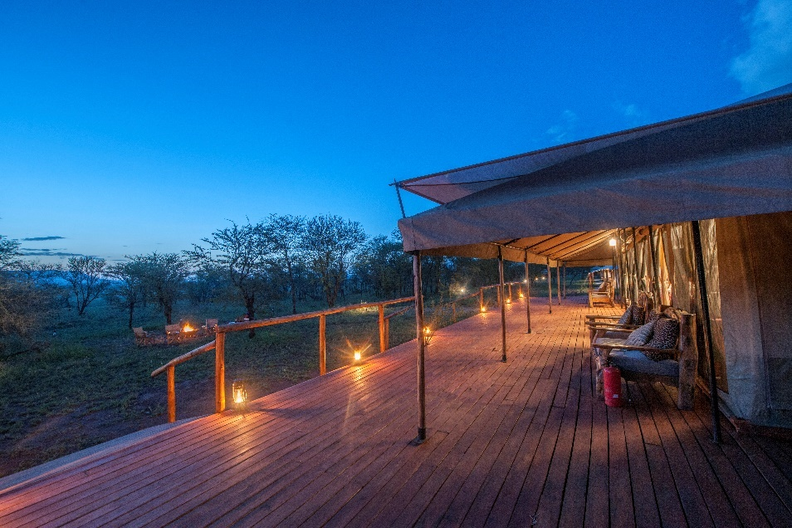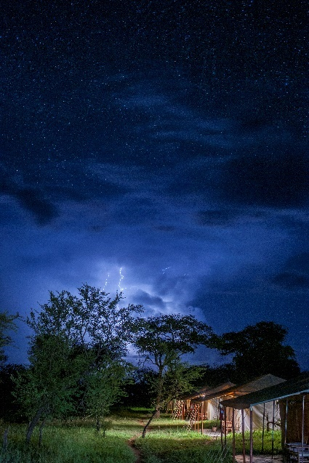

THE followings ARE THE TERMS AND CONDITIONS FOR THE RATE AGREEMENT TO BE SIGNED
Whereby
SERENGETI ACACIA CAMPS TANZANIA LTD
agrees to grant the
TOUR OPERATOR
the following terms and conditions set out herein for
SERENGETI ACACIA CAMPS TANZANIA LTD

- CHILDREN POLICY AND RATES

- Child under 3 years sharing with adults free of charge.
- Child between 3 to 12 years sharing with 2 adults will be charged 50% of adult per person sharing rate.
- Child between 3 to 12 years sharing with 1 adult will be charged 75% of adult per person sharing rate and adult will pay the single room rate
- Child above 12 years will be charged full adult rate. Please note :
- Children under 12 years are not allowed to stay alone in a tent.

- RATE INCLUSIONS AND EXCLUSIONS
Rates include:
- Accommodation Based on Full board (Dinner / Breakfast / Lunch or Picnic lunch box)
- Tea and coffee during meals
Rates exclude:
- Laundry Sodas, wines, champagne spirit, local beer and water
- Game drives Medical evacuation insurance and flying doctors
- Park entry fees Gratuities and items of personal nature (tips to camp crews)
- Flight, airport taxes, and airstrip transfers
- 24 Hours camping fee

- BASIC TERMS
- Rates are exclusive of all Government taxes
- Rates are quoted in USD & Exclusive VAT
- Rates are net and Non-commissionable

- SINGLE SUPPLEMENT
- The single tent rate is applicable for the first 3 rooms per booking, any extra single room will be charged additional USD 100 on a single room rate.

- CHRISTMAS SUPPLEMENT
- A supplement of USD25 per person / per night will be applicable on the 24th, 25th, and 31st December 2019.

- TOUR LEADER RATES
- Serengeti Acacia Camps Limited will grant the agent one person free of charge (double room sharing rate) for the use of a Bona Fide Tour Leader, for every 12 paying guests, subject to availability, and must be requested at the time of booking. Serengeti Acacia Camps Limited reserves the right to share tour leader or accommodate in the Managers Tent.

- DRIVER GUIDE ACCOMMODATIONS AND MEALS
- Driver guides will pay Tsh 10,000/= per driver guide on Full Board on arrival at the camp, driver guides will be accommodated in driver tent.
- Driver guides are allowed to have meals with passengers at no extra cost.

- HONEYMOON AND ANNIVERSARIES
- A bottle of wine can be arranged at an extra cost of USD 30 per bottle.

- PRIVATE BUSH DINNER
- Private Dinner can be arranged for a supplement of USD 30 per person/per meal.

- EXTRA MEALS
- Picnic lunch box: USD 20 per person
- Lunch: USD 25 per person
- Dinner: USD 30 per person

- PROVISIONAL BOOKINGS
- Provisional bookings will be held subject to availability for 10 days only and automatically released if no confirmation is received.

- CANCELLATION POLICY
The following terms will apply for any cancellation or reduction in numbers of rooms or passengers of any booking.
- Between 45 days to 30 days prior to arrival date: 50% cancellation fee will apply
- Between 29 days to 15 days prior to arrival date: 75% cancellation fee will apply
- Less than 14 days or no show: 100% cancellation fee will apply

- PAYMENT POLICY
- 20% deposit on confirmation
- Full payment to be received 45 days prior to client’s arrival.
- All extras to be settled in full before departure.
- Bookings with no full payment settle on the 45th day prior to arrival, will automatically be released from our system
- Cheques returned by the bank will incur a 3% returned cheque fee
- Tour Operator agrees to pay all costs including legal fees incurred in the collection of unpaid invoices

- LIABILITY
- Serengeti Acacia Camps Ltd does not and will not accept any responsibilities for any accident or incident of any nature involving clients/guests and or staff members of any tour company, when traveling to or from our camp or partaking in any activity, arranged by, associated with or owned by Serengeti Acacia Camps Limited
- RATE INCREASE / VARIATION
- The contract rates, terms & conditions mentioned in this agreement are subjected to change without notice: however, every effort will be made to maintain them. In the event of change on government taxes, levies, concession fees or wildlife management fees, Serengeti Acacia Camps reserve rights to pass these on to the agent

- TERMS AND CONDITIONS
- All reservations or bookings should be made by company voucher or email.
- Bookings are confirmed upon receipt of 20% deposit

- VARIATION
- The contractual terms mentioned in this agreement are subject to change without notice. In the event of any changes on Government Taxes or levies affecting the contracted rates or terms herein. Serengeti Acacia Camps Limited reserves the right to pass on any increment to Tour Operators. However, every measure possible will be taken to maintain them.

- CONFIDENTIALITY
- The tour operator confirms that the above contract rates, terms, and conditions are strictly confidential and that no portion of this agreement may be divulged to any third party.

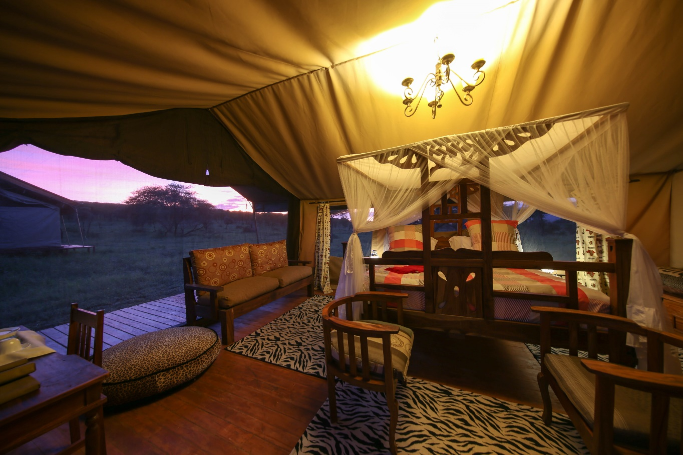
TOUR OPERATOR DETAILS |  |  |  | ACCEPTING THE RATES, TERMS, AND CONDITIONS
Company name:
Contact Name |  | Telephone |  |  | +255
Position |  | Email
Box number |  | City / Town
Date |  | Signature
Account Name: Serengeti Acacia Camps Ltd Account Number USD: 0250200789800  CRDB Bank PLC Arusha Branch  Swift Code: CORUTZTZ Account |  |  | Account Name: Serengeti Acacia Camps Ltd  Account Number USD: 0030029589  Exim Bank LTD Arusha Branch  Swift Code: EXTNTZTZ
