Community Visits

The African Bush Camps community visits are facilitated by the African Bush Camps Foundation (ABCF). ABCF was set up to partner with rural communities located in vulnerable wildlife areas to improve their quality of life and achieve long-term conservation through programs focusing on education, community empowerment, conservation and community infrastructure. By directly linking these benefits to tourism, these communities learn to positively value and avail themselves of wildlife and nature as resources readily available to them.

Full Day Visit Itinerary from Linyanti Bush Camp Projects and Schools

5:30am: Breakfast at camp

6:00am: Depart to Parakarungu Camp Primary School
The 3 hour drive is through a private concession and has the opportunity for excellent sightings along the way.

8:30am-9:00am: Arrival at Parakarungu Primary School
The Initiative/Innervation
African bush camp foundation began operation in 2006 and its vision was to create an opportunity that empowers rural communities located in wildlife areas. As a foundation we want to partner with the local communities and empower them to improve their lives, motivating their knowledge in conservation related issues and facilitate self-reliance. ABCF has a vision on how it approaches this partnerships, it focuses on programs like Education, Conservation, Community infrastructure and Community empowerment.
African Bush Camp has an operation in one of the beautiful undisturbed area in Linyanti/Shaile Botswana and as way of honoring our ABCF tradition of giving back to the community, we have Chosen Parakarungu Primary School to work with under a Government program adopt a school, reason being its location, very remote are and not easy to get there. One other reason is that it is closer to Linyanti bush camp about 65km.
Parakarungu Primary has a total number of 308 students, Girls 155 and 153 Boys. In total the school has 15 Stuff that are fully supported by Botswana Government.

09:30am-10:30am: Kachikau special unit School Visit
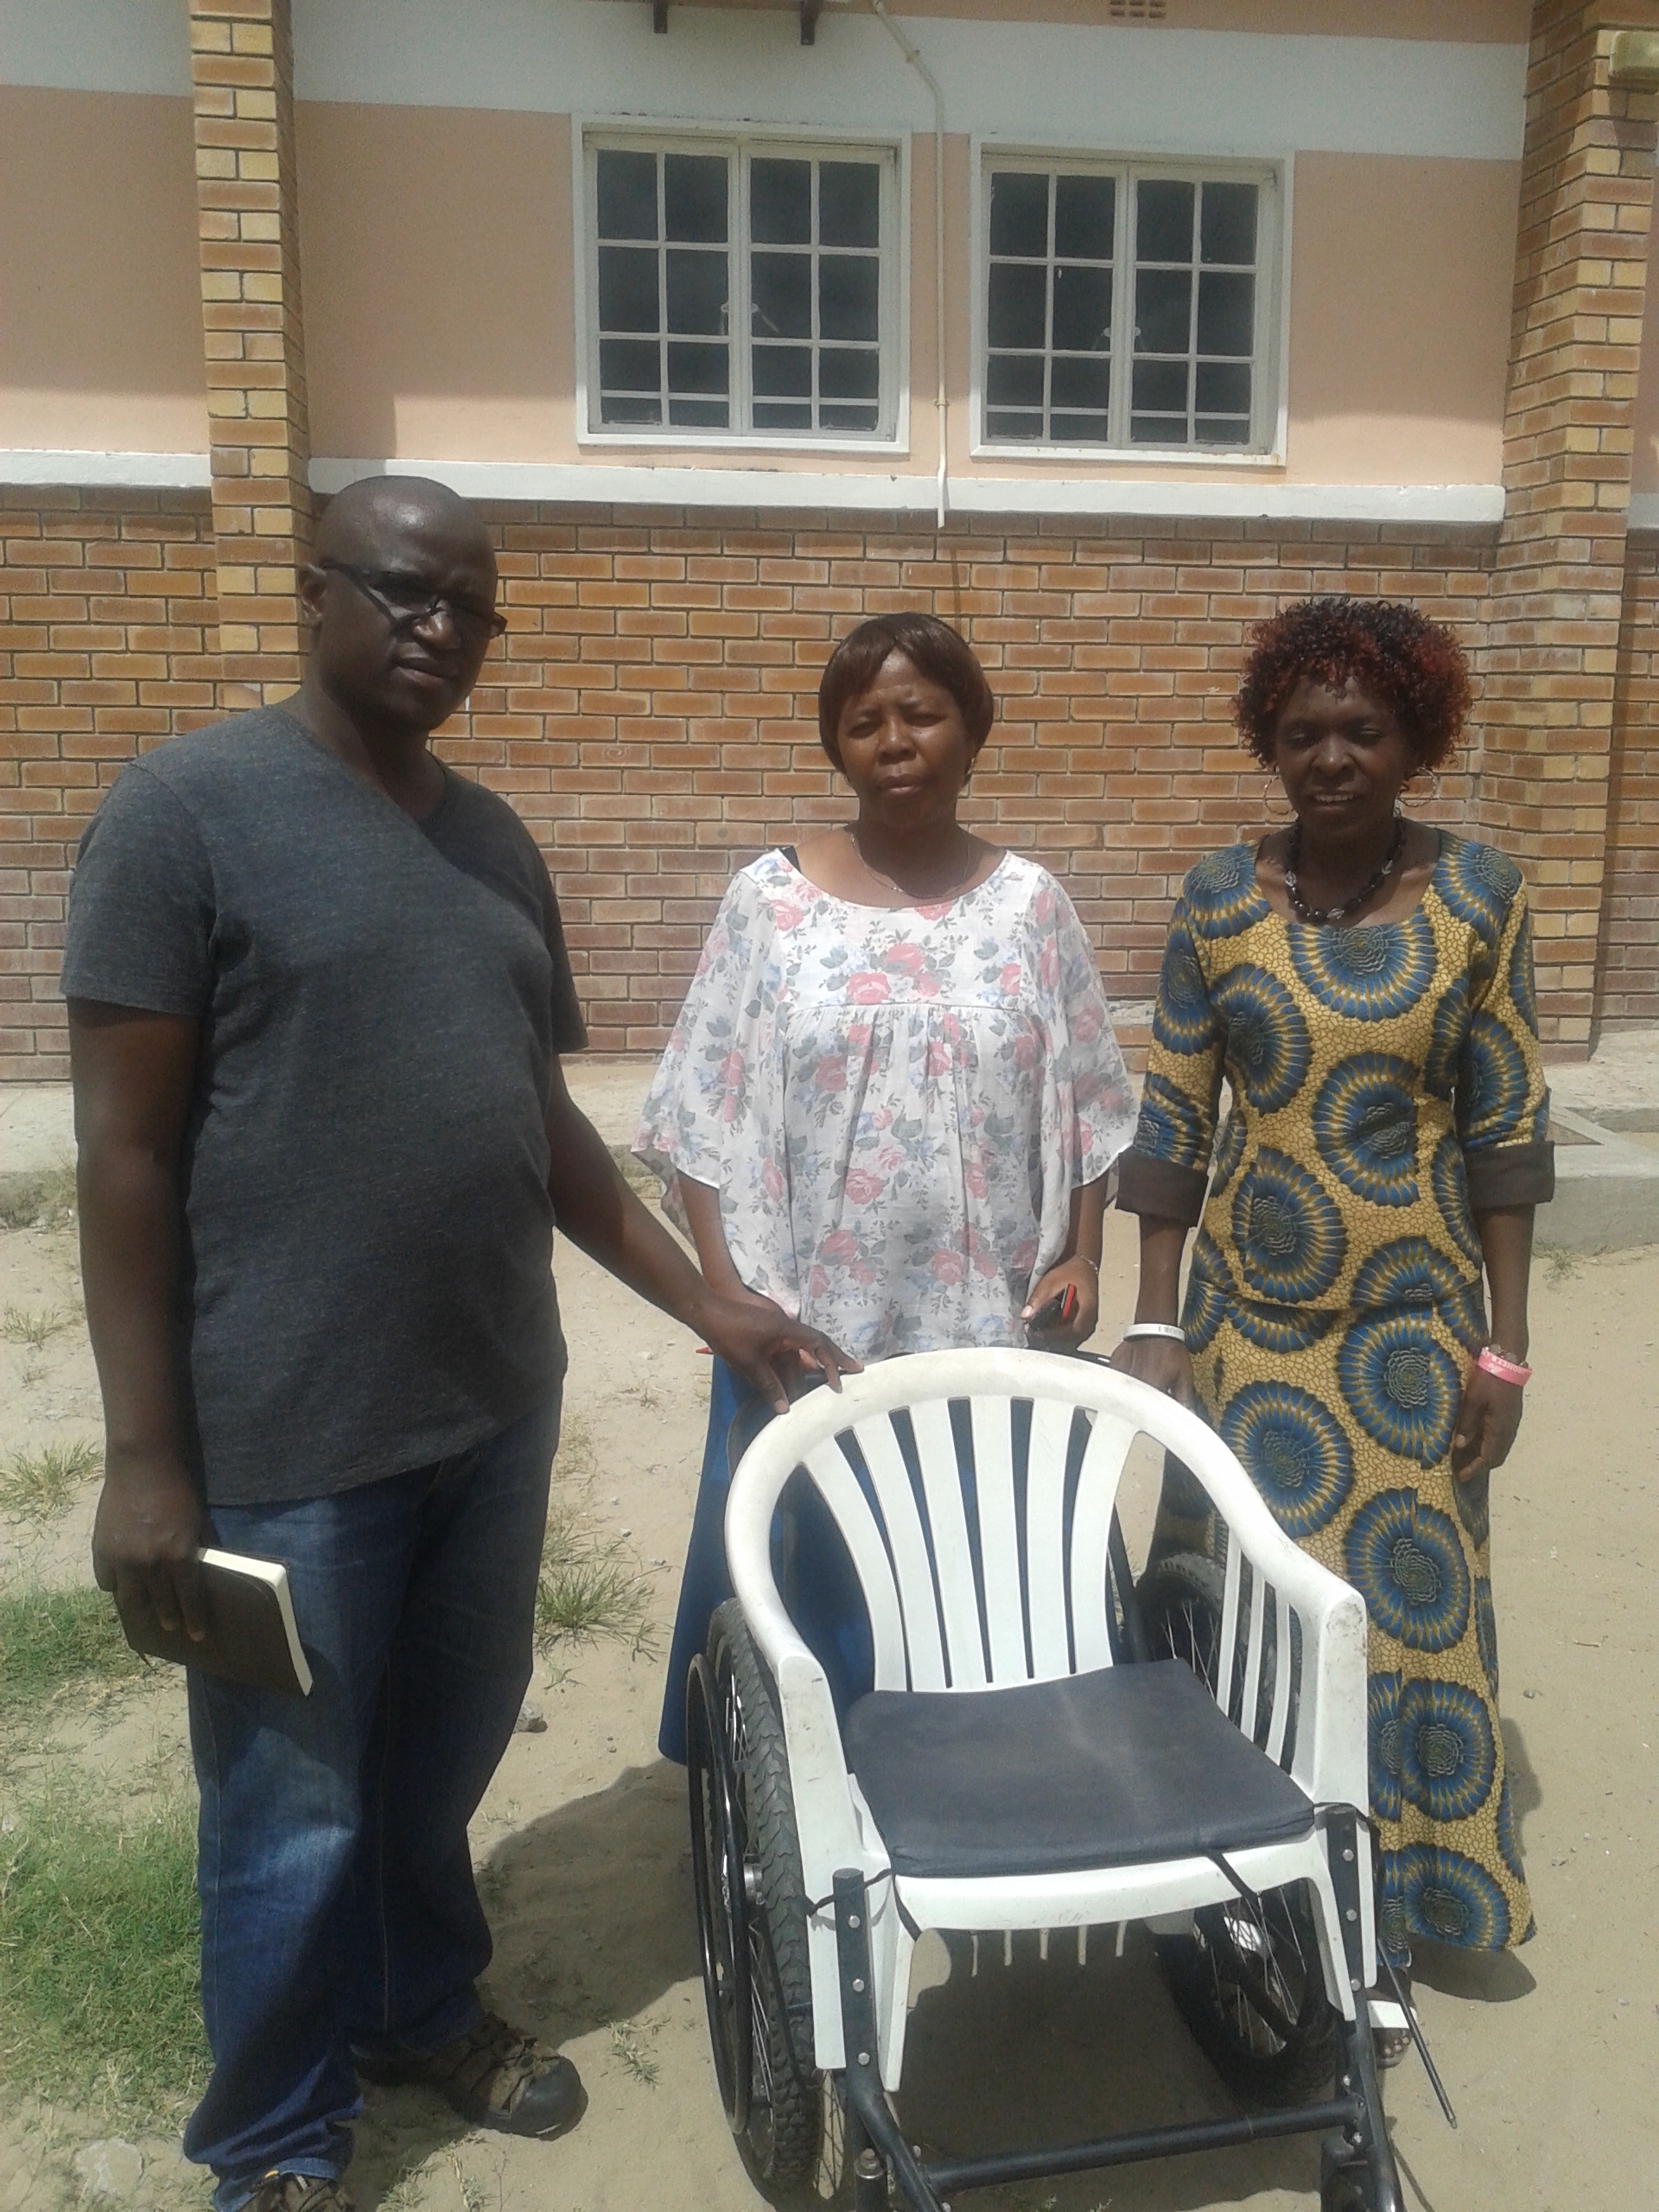 Kachikau Primary School is located in Kachikau Village; it is in the middle of the 5 Chobe enclave villages. The School has 2 sections, one with normal students and the other section with disabled students. During the ABCF need assessment we find out that the special unit has 31 students, 1 6 boys and 15 Girls. The student do not only come from chobe enclave but come as far as Francistown and surrounding area s some even come as far as Gantsi . Some of the student are brought from home to school at the begging of the school teams and will never see their parents until they are sent back home when school closes again. The unit relays at in Government funding for day today running of the school.
The Government has done its best to get the school up and running, the student attend the same classes with other normal students , the have 2 rooms where their sleep 2 sets of bathrooms for boys and girls, and provided 4 care givers.
from the business will then benefit the community because some money will then be used to support venerable groups in the village. E.g. building shelter for the old people who don’t have houses, they will also identify student from Kachikau primary school and support them with uniform

11:30-1200pm: Vuche vuche tour and meeting the ladies
.
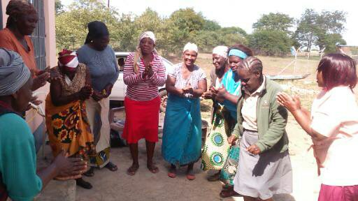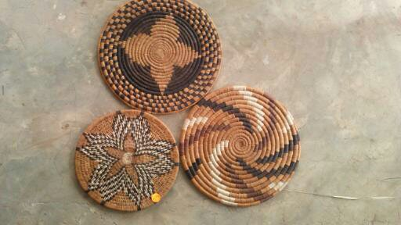

1200-1300pm Guests have traditional food cooked by Vuche Vuche.
Lunch is a traditional style meal prepared by a local homestead featuring foods that they would normally eat on an everyday basis. Packed lunches can be prepared in camp for guests with special dietary needs and those who may not be comfortable with a traditional village prepared meal.

13 30pm departing Vuche vuche and arriving at 1630 – 1700pm

