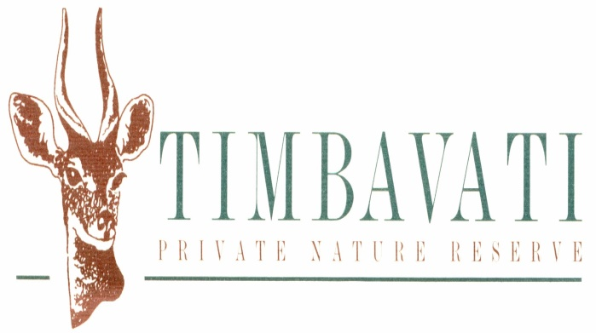

RHINO CHIPPING AND NOTCHING - 2018

This process takes place between May and September only. Should your guests be interested in participating in this exercise, the cost is R 40 000 for 2 Rhino
Please take note of the following:
- This is an opportunity to notch Rhino within the Timbavati Private Nature Reserve. The capture cannot be guaranteed as we border on and am open to the Kruger National Park, the movement of the animals between the two reserves playing a role.
- The availability of a government official will determine the outcome of the permit application for a specific operation.
- Only two (2) bookings per month will be allowed.
- In the event of no animals being found during the operation, the client/lodge will be responsible for the cost of the helicopter search time only.
- Each chipping can be attended by 1 – 18 guests. A maximum of 2 vehicles.
- The lodge to provide transport and a guide for the entire process.
- Rhino chipping only can take place between Monday and Friday.
- This offer is open to guests of lodges within the Timbavati Private Nature Reserve only.
- Please inform Almero Bosch on almero@timbavti.co.za at least 4 weeks prior to when you would like to participate with the details – this is required as we need to arrange the permits, helicopter, vet, provincial representation etc.

