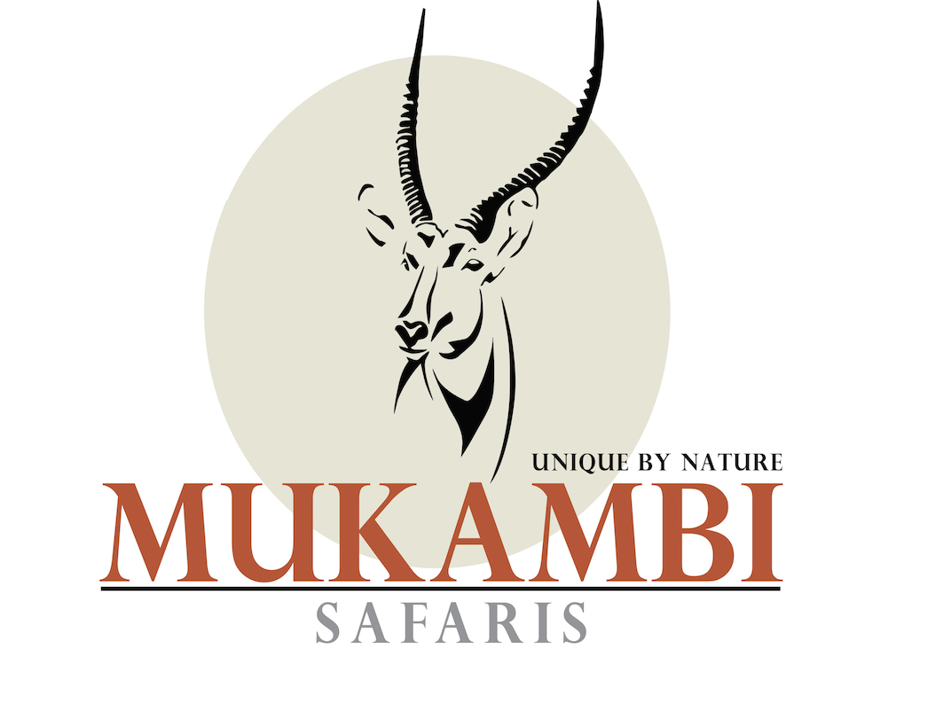
MUKAMBI SAFARI LODGE
FIG TREE BUSH CAMP
BUSANGA PLAINS CAMP

Tel: +260 (0) 974424013
Skype: mukambi.reservations
Email: info@mukambi.com
Web: www.mukambi.com

Mukambi, 13 August, 2020

Mukambi Safaris Covid-19 Terms and Conditions

Dear Valued Partner,

We trust this email finds you well in these challenging times! The Covid-19 pandemic has lasted a longer than most of us expected and doesn’t seem to show any signs of letting up. Nevertheless there are positive developments as well. Zambia has now opened its borders for international travel and the government has put measures in place to ensure travel resumes in a safe environment. We therefore find it imperative that we adjust our current Terms and Conditions to stimulate your bookings during this period.

To stimulate new bookings during the Covid-19 pandemic we will implement the following Terms and Conditions:
- No deposit payments will be required until 31 days before the guest’s travel dates. At this point the full payment will be due.
- Deposits will be fully refundable if cancellation due to Covid-19 takes place (i.e. Zambian authorities restrict travel or a guest is tested positive for Covid-19) 15 or more days prior to travel.
- A 50% cancellation fee will apply to a cancellation within 14 days. This will not apply if Zambian authorities restrict travel or a guest is tested positive for Covid-19 within this period.
- These conditions apply for new bookings made on normal rates. Specials with different terms and conditions are excluded.

Our terms and conditions will be back to normal once normal travel resumes and Covid-19 is no longer considered a pandemic or at least by the end of 2021.

We hope this will assist with future bookings!

Best regards,

The Mukambi team

