HARTLEY’S CROCODILE ADVENTURES – SELF DRIVE PRODUCT
TOUR NAME: | Hartley’s Crocodile Adventures
LOCATION: | Hartley's Crocodile Adventures is located 40 km. north of Cairns & 25 km. south of Port Douglas.  Lot 10 Harry Freeman Drive off the Captain Cook Highway.  Call 07 40553576 should you have any questions regarding your booking.
Tour Code: | HCA - SD
Style: | Wildlife Tour
Hero Image: | 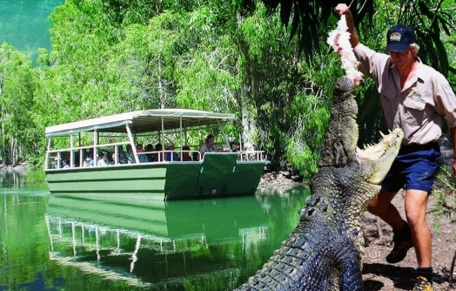
Description | Hartley’s Crocodile Adventures 2010 Major Award-winning attraction is simply the best place to see crocodiles and local wildlife in the North.  Nestled in the picturesque Wangetti Valley, in the heart of the Wet Tropics World Heritage Area you will see crocodiles in a natural Melaleuca Wetland Lagoon. You will find Cassowaries in a rare riverine rainforest; kangaroos and emus in an expansive woodland; free flight predatory birds; iconic marsupials like koalas and wombats; colourful reptiles from abroad, plus our sustainable crocodile farm.  With over 2100 metres of timber boardwalks and pathways these will take you on a journey of discovery through woodlands and rainforest.  Enjoy the entertaining and educational wildlife presentations including, our snake show, crocodile attack show, crocodile farm tour, cassowary feeding and of course time to feed the wallaby’s and kangaroos.  Enjoy a tour of the wetlands on a boat cruise and watch crocodiles, birds and the wildlife of the coastal melaleuca habitat.  Learn about sustainable use and conservation on our crocodile farm tour.  The Gondwana Gateway’ is an innovative addition to this award-winning attraction, it is best described as the ‘bridge between two worlds’ The interpretative signage explains how isolation and adaption shaped our unique fauna over time.  Our Gallery of Living Art is open from 9.00am to 5.00pm see colourful snakes & lizards from Australia and abroad. Marvel at the Komodo Dragon and giant Reticulated Python.  Sit back and relax and enjoy a delicious meal in Lilies Restaurant overlooking Hartley’s Lagoon (own expense) and find that perfect gift in the Paperbark Gift Shop.  Also see our Luxury Crocodile Skin Leather range “Croctique” where you may fine that perfect gift bespoke designer Crocodile Leather Handbags, Men’s and Ladies Wallets and other beautifully hand crafted Crocodile Skin Leather products.
Default Allotment: | Free Sell: X. This allows any number of tours to be sold
Meta Data Description: | See Crocodiles, Kangaroos, Snakes, Koalas and other wildlife at Hartley’s Crocodile Adventures. Entry includes Lagoon Cruise and Interactive Wildlife presentations.
Tour Introduction: | Hartley’s Crocodile Adventures is simply the best place to see crocodiles and local wildlife in Tropical North Queensland.
Tour Highlights: | - Cruise on our Lagoon and see Crocodiles feeding  - Free Wildlife presentations  - Koala encounters  - Restaurant on site for delicious meals and snacks  - Walk through free flying bird aviary  - In the heart of Wet Tropics World Heritage Area  - Crocodile Farm Tour
Tour Description:
Minimum Pax No for tour to run: | 1 person
Disabled Access: | Yes
Fitness level required: | Low
Location, how to get there: | Hartley’s Crocodile Adventures are located 100 metres off the Captain Cook Highway at Wangetti. It is 40 minutes north of Cairns and 20 minutes south of Port Douglas at 15 minutes north of Palm Cove.  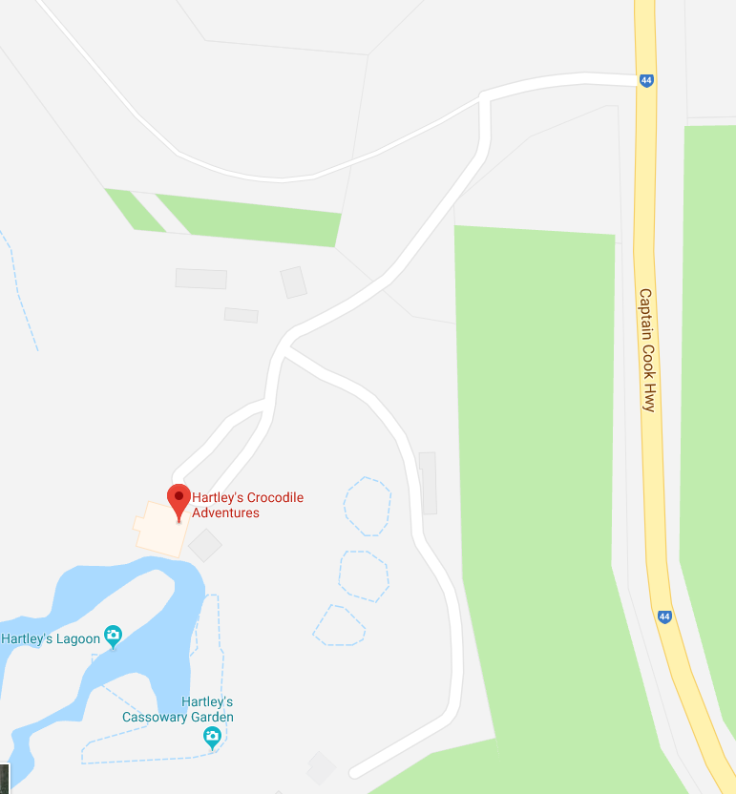
Opening Hours: | 8.30 am to 5.00 pm daily except closed on Christmas Day 25th December, 9th June Cairns Ironman, restricted trading 1:30 - 4:00pm on ANZAC Day 25 April). (Allow yourself at least 3 – 4 hours to go through the park)
Facilities Included in Price: | Entry to Hartley's Crocodile Adventures  Boat cruise (Bookings are NOT taken for the Boat Cruise. Boat Cruise times are allocated upon arrival.)  Daily wildlife presentations.
Facilities for purchase: | - Strollers  - Souvenir Shop  - Lilies Licensed Restaurant  - Wildlife photos  - Wheelchair - free of charge but please call us to book it if required we only have one on site
What to bring & Wear: | Comfortable walking shoes, preferable no thongs  Hat, sunscreen, water  Camera  $$ for souvenirs, food & drinks
Cost: | Self-Drive Adults $39.00 Child (4-15yrs) $19.50 Family $97.50 (2ad + 2ch) Prices valid to the 31st March 2019.
Duration: | Park open from 8.30am till 5.00pm
Tour Code: | HCA - SD
Sister Parks: | We also have Kuranda Koala Gardens and Kuranda Birdworld

