Community Visits

The African Bush Camps community visits are facilitated by the African Bush Camps Foundation (ABCF). ABCF was set up to partner with rural communities located in vulnerable wildlife areas to improve their quality of life and achieve long-term conservation through programs focusing on education, community empowerment, conservation and community infrastructure. By directly linking these benefits to tourism, these communities learn to positively value and avail themselves of wildlife and nature as resources readily available to them.

Full Day Visit Itinerary From Somalisa Camp to the Hwange Projects and Schools

6:00am: Breakfast at camp

6:00am: Depart to Main Camp Primary School
The 2 hour drive is through the park and has the opportunity for excellent sightings along the way.

8:00am-9:00am: Arrival at Main Camp Primary School
We have been sponsoring this school attended by the children of National Parks Employees since 2006. The school has an enrollment of 127 children and we are currently providing scholarships for 33 orphaned and vulnerable children as well as supporting the school through a garden, school materials including stationery, a computer room, paying for an additional teacher at the school, and sponsoring events such as World Environment Day celebrations. As you visit and tour the school, the Marimba band which fundraises for the school at the National Parks tourist restaurant will entertain you and move you to their infectious rhythms.

9:30am-11:30am: Mambanje Primary School Visit
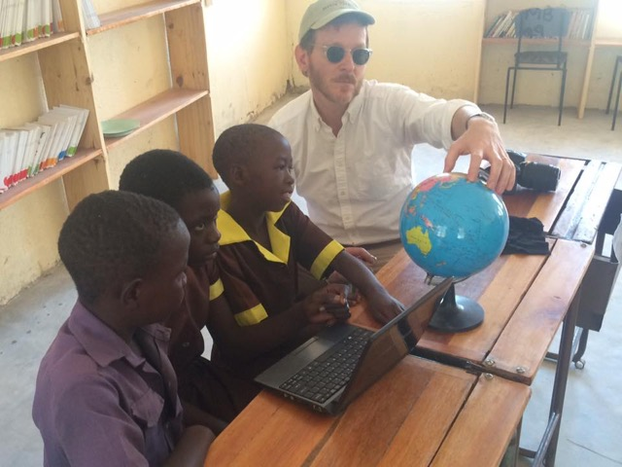
Mambanje Primary School is one of the most remote and underdeveloped schools in Hwange and the African Bush Camps Foundation has partnered with them in addressing their development challenges and has for the past 3 years engaged with the school in supporting income generating projects, infrastructure building and support o f orphaned and vulnerable children. The tour of the school will include meeting with students and teachers and viewing some of the developments which include the submersible pump borehole, solar power system, library and e-learning centre, and income generating projects which include a school garden, chicken rearing business and tuck-shop. ABCF (and its partners) is also providing scholarships to 90 orphaned and vulnerable children, providing an additional teacher at the school and has painted the school and repaired furniture.
11:30am-12:30pm: Meeting with the Mambanje Lion Guardian and tour of the Mambanje Cattle Boma
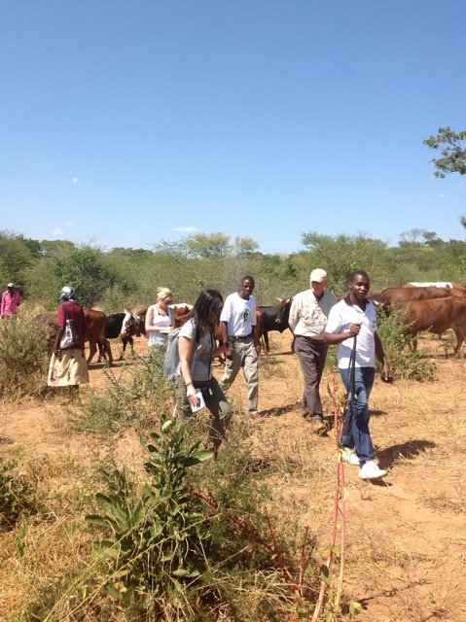
The Mambanje community is located in an area with a high lion population which often presents a lot of challenges for the community in terms of safety for themselves and their livestock. Through Lion Guardian programs that help mitigate conflict between humans and lions, monitor lion trends and patterns, provide early warning systems, and prevent lion hunting, the Mambanje community is learning to live in harmony with not only lions but all the wildlife around them. The current Lion Guardian, Polite Chipembere was selected through an interview process led by the Hwange Lion Research Project and the local community Leadership. Polite is helping to mak e the community more aware of their wildlife surroundings and has led the erection of the mobile cattle boma in Mambanje.

As an additional conservation effort to the Lion Guardian at Mambanje, ABCF and its partners have also come together to put up a mobile cattle boma for the community. The boma is helping to scale up conservation efforts and help lessen conflict between the community and wildlife by protecting their cattle from attacks from lions. It is empowering the community to be in control of improving their entire ecosystem as the mobile boma is improving the quality of grazing, raising the water table, enabling rivers to flow again and fertilizing the soils in the fields as the boma is rotated from one villagers field to the next leaving each field fully fertilized for 3 years. This really gives control back to the community to management their own land, resuscitating their main livelihood which is agriculture. ABCF will also be extending a livestock health programme where cattle in the Mambanje village and boma will receive veterinary care.

12:30pm-1:30pm: Traditional Lunch at Mambanje Village
Lunch is a traditional style meal prepared by a local homestead featuring foods that they would normally eat on an everyday basis. Packed lunches can be prepared in camp for guests with special dietary needs and those who may not be comfortable with a traditional village prepared meal.

2:00pm-3:30pm: Thandanani and Vukani Projects in Dete
Dete is a small railway re-crewing depot and developing town on the Bulawayo-Hwange-Victoria Falls railway line lying close to the border of Hwange National Park. The town is comprised of three main suburbs which Mtuya, Railways, and Soweto suburbs. Mtuya is made up of predominantly mud houses with thatch roofs, while Soweto is more urban looking with brick houses and modern roofing. Railways is a smaller and less densely populated suburb which was built by the railways for its workers but is now mostly inha bited by the wealthier Dete residents. It is common for residents of Dete to be visited by wildlife around their homes with elephants constantly terrorizing the communities.

The Vukani Group is a group of 10 people based in Mtuya, Dete who started a beading and jewelry making project in 2011. The jewelry-making project features pieces that are hand-crafted using recycled materials – like magazines – which are rolled into beads and then used to create unique earrings, necklaces and bracelets. This is a place where poverty levels are high and education is low. There is no electricity and little running water and due to the HIV/AIDS epidemic, there are many orphans and vulnerable children who are cared for by their grandparents. The group uses their earnings to take care of such orphans as well as cover other living needs.

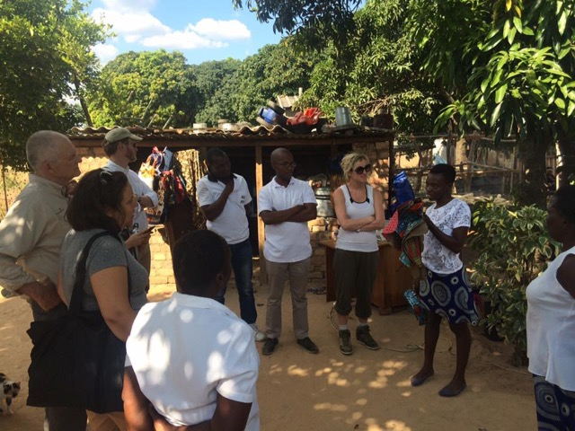
The Thandanani Sewing Project is a group of 5 women aged 22-61, that came together in the Dete suburb of Soweto in 2009. The 2 widows, 2 single mothers and 1 married woman owned three sewing machines between them, but they had no funds to buy material to get started. ABCF supported them in capitalizing their business. Due to economic hardship all group members are struggling to earn a living hence the eagerness to grab the opportunity to sew to earn a living. They received funds in August 2012 through the Foundation, and in September 2012 they made their first sales through the ABC camp curio shops in all ABC camps. The group is disciplined and dedicated, and by bringing together their skills and resources, they have been able to better their economic circumstances.

3:30pm: Head back into the Park
This will be the same route as in the morning but may be adjusted into a full game drive.

Arrive in Camp: 5:45pm or later

General Guidelines
- Candy and balloons are not on the needs list as they are harmful for the children and the environment for the following reasons:
- Few of the children benefiting from these projects have access to toothpaste, toothbrushes, or a dentist. The candy promotes cavities.
- The balloons once they become deflated are a choking hazard for local wildlife.

Instead of taking candy or balloons, use that space for additional requested supplies, as they are priceless. These can include:

General School Supplies:
Chalk, Colored Pencils, Crayons, Erasers, Geometry Sets, Handheld Pencil Sharpeners, Markers, Mathematics Sets, Pencils, Pens, and Solar Calculators
Reference Materials:
(English) Atlases and Encyclopedias

Wall Charts:
(English) Human Body, Language, Math, Science, and World Maps

Text/Reading Books:
(English) Age Appropriate Story Books

Art Supplies:
Acrylic Paints and Brushes and Watercolor Paints and Brushes

Computer Hardware/Software:
Flash Drives/Memory Sticks and Working Laptops

Educational Games/Toys:
Stuffed Animals/Soft Toys

Sports/Outdoor Activity:
Inflation Pumps, Netball/Basketballs, New or Used Sports Equipment, Soccer Balls, Volleyballs, and Volleyball Nets

Clothing/Shoes:
New or Gently Used Children’s Clothing and Shoes (particularly Athletic Shoes) and Nursery School-Sized Clothes and Shoes

Gardening Supplies:
Organic and Bio-Dynamic Vegetable Seeds – Contact Us.

Art Supplies for Artist Initiatives and Community Produced Projects:
Craft Glue, Craft Scissors, Earring Hooks, Fashion Magazines, Gage Wire, Glass Beads for Bead Work, Knitting Needles, Sewing Needles, Sewing Scissors, Tape Measures, Thread, and Wire Cutters

- During the community and school visits, there may be times when guests will see extreme poverty situations and may feel compelled to help on the spot. We discourage this and would advise guests to talk to the foundation representatives on the ground to discuss ways in which they can help in more strategic and sustainable ways.

- If approached for assistance, kindly decline and refer the person or group to the ABC representative accompanying you.

- As this is a learning exchange, guests are invited to interact freely with students and community members during the visit.

Logistics and charges

There is no charge for the actual visit to the schools and projects however there are the following costs which need to be covered by guests:
- A standard road transfer cost is charged from Somalisa to Main Camp of US$40 per person
- If it is the day of transfer to or from Somalisa, instead of charter plane from Manga 3, the Safari - Logistics transfer can drop or collect guests from Hwange Main Airport, which is 10 minutes drive from Dete. If guests are departing from Hwange Main Airport, there is a departure tax charge of US$15 per person. This is ideal for the guests day of departure, guests will road transfer to Main Camp, conduct full village visit and arrive at Hwange Main Airstrip for the scheduled onward charter flight.
Should lunch be included at the homestead visit, a cost of US$15 per person is charged to cover the cots of lunch.

