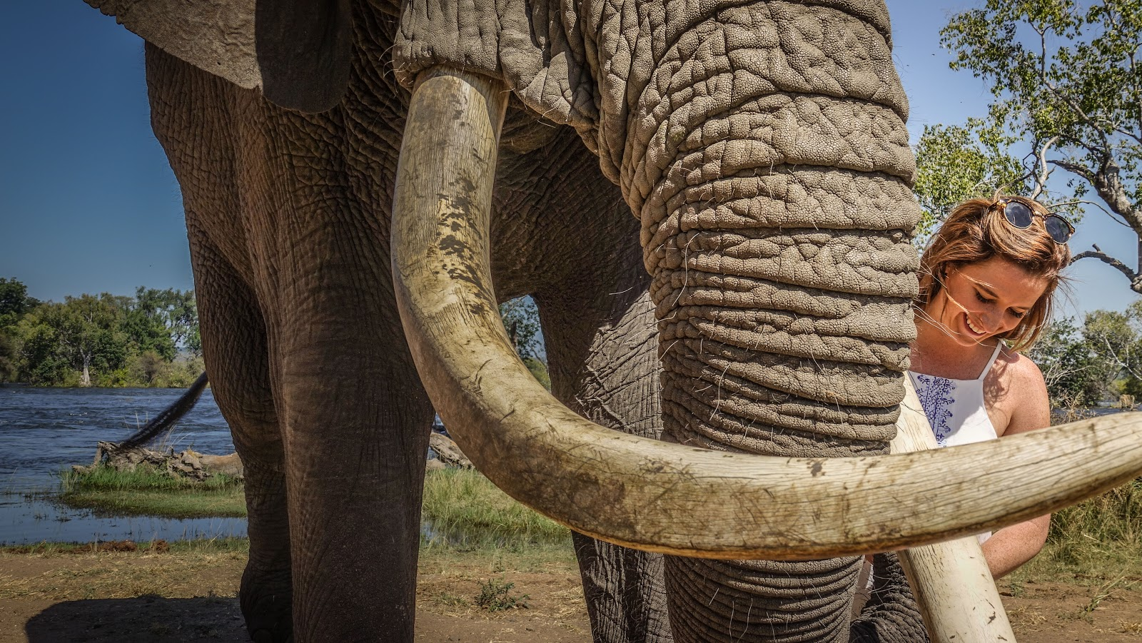

ELEPHANT CAFE

Activities Options:

Pickup times from Lodges within Livingstone town

Lunch
Boat Transfer – 10H30 – 14H30
Road Transfer – 11H00 – 14H30
High Tea
Boat Transfer – 14H30 – 18H30
Road Transfer – 15H00 – 18H30
Dinner
Boat Transfer – 16H00 – 20H00
Road Transfer – 16H30 – 20H00

Please allow for a 15 minute variation either way on pickup times due to logistics

