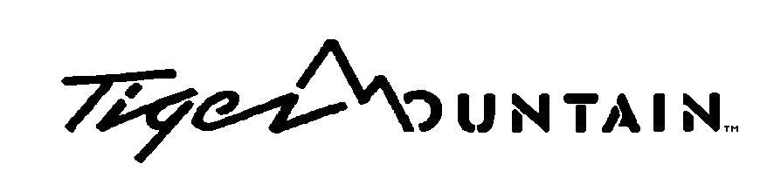

POKHARA LODGE

Company Profile

Tiger Mountain owes its name to its founding companies, Tiger Tops and Mountain Travel founded in 1965. The companies, which came together in the early 1970s, pioneered high quality adventure tourism in Nepal – jungle safaris, Himalayan trekking, white water rafting, tourism in Bardia National Park, film location management, tourism policy consulting, international tourism development and marketing. Setting the standards for environmentally responsible conservation tourism from the seventies, Tiger Mountain now works on the latest models of sustainable tourism. We ensure that all our stakeholders derive sustained benefit: guests, staff, local communities, the government, and our shareholders. Tiger Mountain Pokhara Lodge is independently audited for its responsible tourism annually – one of only 2 hotels in Nepal – by JUSTreport UK.

Sir Edmund Hillary KG opened the Lodge in late 1998. Perhaps the best designed village resort in Nepal, the lodge has won several prestigious awards including the Best New Eco-tourism Product Eco Awards 1999 and is Highly Commended by Conservation International (Eco-tourism Excellence Awards 2000). National Geographic Adventure has included the Lodge as one of the World’s Top 50 Eco-Lodges – the only one of its kind in the sub-continent and invited the lodge to join their top 25 Unique Lodges of the World.

Employing 40 Nepali staff, ownership is British – Marcus Cotton is the majority shareholder, resident in Nepal for over 28 years but with a background in heritage properties, insurance, agriculture, off-shore sailing and estate management. Lisa Choegyal is a leading consultant with Tourism Resource Consultants NZ, writer and editor of several leading travel publications and is Honorary Consul for New Zealand in Kathmandu. She has lived in Nepal since the mid-1970s and works as Marketing Director for Tiger Mountain. Tiger Tops having divested its shareholding in 2016 to the co-owners, Tiger Mountain is now exploring a range of new tourism options in Nepal.

The lodge is the premier hotel in Pokhara, Nepal’s second tourism destination after Kathmandu. It is one of the top properties in Nepal in terms of revenue per guest. It sets the standards for sustainable, high-budget tourism in Nepal and has recently been awarded as one of the most significant tax payers in Pokhara area.

