Community Visits

The African Bush Camps community visits are facilitated by the African Bush Camps Foundation (ABCF). ABCF was set up to partner with rural communities located in vulnerable wildlife areas to improve their quality of life and achieve long-term conservation through programs focusing on education, community empowerment, conservation and community infrastructure. By directly linking these benefits to tourism, these communities learn to positively value and avail themselves of wildlife and nature as resources readily available to them.

Hwange Schools and Projects Half Day Visit Itinerary
*Please note that this 4 hour round trip itinerary can be booked either on the way to or from Somalisa camp by road transfer. There is a charge for the vehicle transfer to or from Somalisa Camp as per the standard road transfer charge of US$40 per person. Arrival or departure at Hwange Airport attracts a US$15 per person tax charge if departing by charter plane from Hwange Main Airport.

8:00am-9:30am: Arrive at Main Camp Primary School
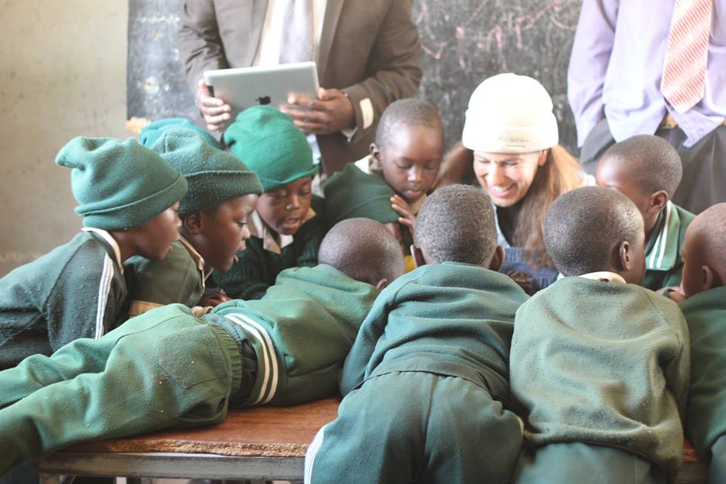
We have been sponsoring this school attended by the children of National Parks Employees since 2006. The school has an enr ollment of 127 children and we are currently providing scholarships for 33 orphaned and vulnerable children as well as supporting the school through a garden, school materials including stationery, a computer room, paying for an additional teacher at the school, and sponsoring events such as World Environment Day celebrations. As you visit and tour the school, the Marimba band which fundraises for the school at the National Parks tourist restaurant will entertain you and move you to their infectious rhythms.

10:00am-12:00pm: Thandanani and Vukani Projects in Dete
Dete is a small railway re-crewing depot and developing town on the Bulawayo-Hwange-Victoria Falls railway line lying close to the border of Hwange National Park. The town is comprised of three main suburbs which Mtuya, Railways, and Soweto suburbs. Mtuya is made up of predominantly mud houses with thatch roofs, while Soweto is more urban looking with brick houses and modern roofing. Railways is a smaller and less densely populated suburb which was built by the railways for its workers but is now mostly inha bited by the wealthier Dete residents. It is common for residents of Dete to be visited by wildlife around their homes with elephants constantly terrorizing the communities.

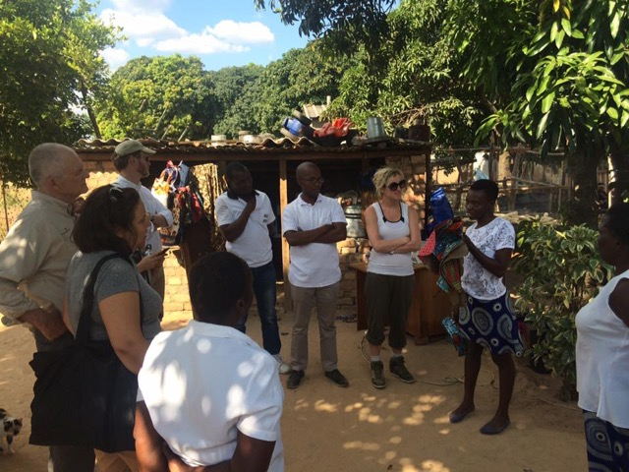
The Vukani Group is a group of 10 people based in Mtuya, Dete who started a beading and jewelry making project in 2011. The jewelry-making project features pieces that are hand-crafted using recycled materials – like magazines – which are rolled into beads and then used to create unique earrings, necklaces and bracelets. This is a place where poverty levels are high and education is low. There is no electricity and little running water and due to the HIV/AIDS epidemic, there are many orphans and vulnerable children who are cared for by their grandparents. The group uses their earnings to take care of such orphans as well as cover other living needs.

The Thandanani Sewing Project is a group of 5 women aged 22-61, that came together in the Dete suburb of Soweto in 2009. The 2 widows, 2 single mothers and 1 married woman owned three sewing machines between them, but they had no funds to buy material to get started. ABCF supported them in capitalizing their business. Due to economic hardship all group members are struggling to earn a living hence the eagerness to grab the opportunity to sew to earn a living. They received funds in August 2012 through the Foundation, and in September 2012 they made their first sales through the ABC camp curio shops in all ABC camps. The group is disciplined and dedicated, and by bringing together their skills and resources, they have been able to better their economic circumstances.

12:00pm: Proceed to Somalisa camp or to Hwange Airport for departure

General Guidelines
- Candy and balloons are not on the needs list as they are harmful for the children and the environment for the following reasons:
- Few of the children benefiting from these projects have access to toothpaste, toothbrushes, or a dentist. The candy promotes cavities.
- The balloons once they become deflated are a choking hazard for local wildlife.

Instead of taking candy or balloons, use that space for additional requested supplies, as they are priceless. These can include:

General School Supplies:
Chalk, Colored Pencils, Crayons, Erasers, Geometry Sets, Handheld Pencil Sharpeners, Markers, Mathematics Sets, Pencils, Pens, and Solar Calculators
Reference Materials:
(English) Atlases and Encyclopedias

Wall Charts:
(English) Human Body, Language, Math, Science, and World Maps

Text/Reading Books:
(English) Age Appropriate Story Books

Art Supplies:
Acrylic Paints and Brushes and Watercolor Paints and Brushes

Computer Hardware/Software:
Flash Drives/Memory Sticks and Working Laptops

Educational Games/Toys:
Stuffed Animals/Soft Toys

Sports/Outdoor Activity:
Inflation Pumps, Netball/Basketballs, New or Used Sports Equipment, Soccer Balls, Volleyballs, and Volleyball Nets

Clothing/Shoes:
New or Gently Used Children’s Clothing and Shoes (particularly Athletic Shoes) and Nursery School-Sized Clothes and Shoes

Gardening Supplies:
Organic and Bio-Dynamic Vegetable Seeds – Contact Us.

Art Supplies for Artist Initiatives and Community Produced Projects:
Craft Glue, Craft Scissors, Earring Hooks, Fashion Magazines, Gage Wire, Glass Beads for Bead Work, Knitting Needles, Sewing Needles, Sewing Scissors, Tape Measures, Thread, and Wire Cutters

- During the community and school visits, there may be times when guests will see extreme poverty situations and may feel compelled to help on the spot. We discourage this and would advise guests to talk to the foundation representatives on the ground to discuss ways in which they can help in more strategic and sustainable ways.

- If approached for assistance, kindly decline and refer the person or group to the ABC representative accompanying you.

- As this is a learning exchange, guests are invited to interact freely with students and community members during the visit.

Logistics and charges

There is no charge for the actual visit to the schools and projects however there are the following costs which need to be covered.
- A standard road transfer cost is charged from Somalisa to Main Camp of US$40 per person
- If it is the day of transfer to or from Somalisa, instead of charter plane from Manga 3, the Safari - Logistics transfer can drop or collect guests from Hwange Main Airport, which is 10 minutes drive from Dete. If guests are departing from Hwange Main Airport, there is a departure tax charge of US$15 per person.
Should lunch be included at the homestead visit, a cost of US$15 per person is charged to cover the cots of lunch.

