DINING

Guests are introduced to a delightful dining experience at BrijRama Palace. The Palace offers multiple cuisines that also includes not only international but also traditional local fare in a choice of dining locations. From fine dining to an al-fresco experience or a quaint lounge, BrijRama has it all.

Our menu selections are exquisitely crafted by a team of highly trained chefs to offer unrivaled dining in Varanasi.

Guests should note that due to the location on the Ghats and proximity to the holy Ganges,

BrijRama Palace does not serve Non-Vegetarian preparations and Alcoholic Beverages

Private Dining
We arrange a candlelight dinner in an exclusive location of the Palace for Guests. The experience is specially created for you by our Chef (on prior reservation only)

River Dining
We offer you an unforgettable Dining experience by Candlelight on a boat, along the waters of the Ganges (on prior reservation)

DARBHANGA
Soak in spirituality with every bite! Traditional Indian vegetarian delicacies come to life in this fine dining outlet that overlooks the Ganges. Flavors and ingredients descended from the Vedas. All our recipes have a story to tell.
One can enjoy a quiet meal, personalized to one’s taste sitting amidst the beauty of restored ceilings and walls rich with a bouquet of frescos and artwork.
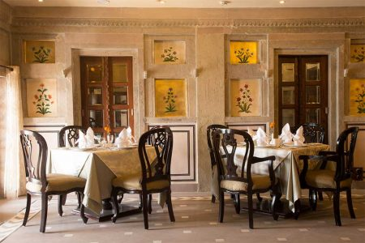
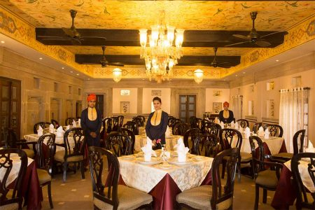
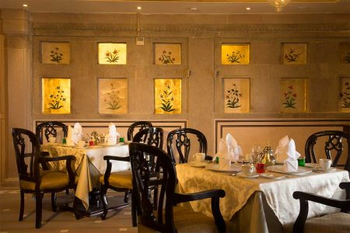
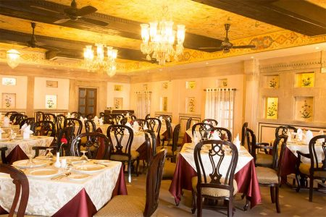

KAMALYA
Kamalya Café & Terrace, offers an excellent selection of teas & freshly roasted coffees. True to the tradition of the region, you are spoiled for choice of ‘Thandai’, flavoured milk & Saffron based coolers.
Accompanying the beverage list is the chef’s signature selection of dishes offering regional and international flavors.
A stay at Varanasi is not complete till you have savored our typical Street Food offerings of ‘Chaat’. Traditional & lightly spiced tangy bites that offer an explosion of flavors not experienced before.
Kamalya offers seating indoors and alfresco seating areas overlooking the Ganges.
There is also a Coffee Lounge Library with a collection of books about the region and the cultural heritage of India.
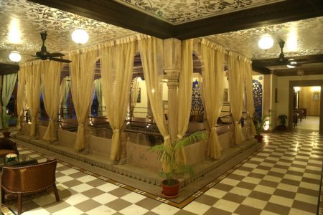
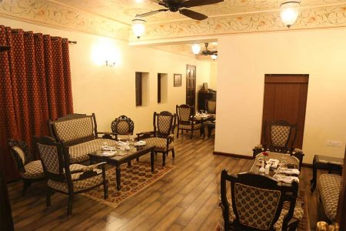
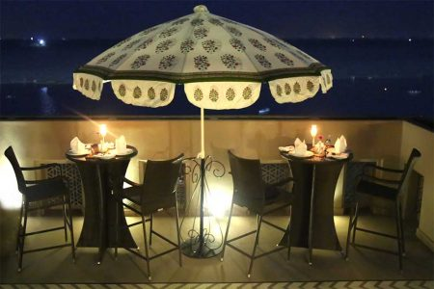
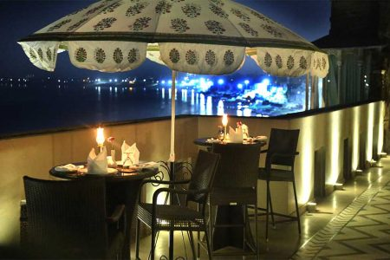

VENUES

History and tradition go hand in hand, celebrate your special moments at our picturesque open-air venues. At Brijrama Palace, we create special experiences not just for dining but also for memorable cultural evenings with traditional musical and dance performances.

Udayan
Udayan, the roof top terrace offers breath taking views of the river and the old city from sunrise in the morning to the brightly lit crescent ghats at night. Udayan is available for private events of up to 125 guests.
Udayan hosts rejuvenating yoga and meditation sessions alongside the rising sun for guests.

Kamalya Terrace
Our 2nd floor terrace that offers a beautiful view of the river below with special lighting effects. The venue can host private events of up to 50 guests.
